# COVER PAGE

**CYBER SHUJAA PROGRAM**

**WEEK 7 ASSIGNMENT REPORT**

**THEME:** **LINEAR REGRESSION MODELLING USING PYTHON**

**STUDENT NAME: DOROTHY AWINO ONGONGA**

**STUDENT ID: CS-DA01-25075**

**DATE: 8TH-JULY-2025**

**JUPYTER NOTEBOOK LINK:** [**https://www.kaggle.com/code/awino614/linear-regression-model**](https://www.kaggle.com/code/awino614/linear-regression-model)

**GITHUB LINK:**

**GOOGLE COLAB LINK:** [**https://colab.research.google.com/#fileId=https%3A//storage.googleapis.com/kaggle-colab-exported-notebooks/awino614/linear-regression-model.0ee944ae-5c12-4e08-be5e-f73a4c59825a.ipynb%3FX-Goog-Algorithm%3DGOOG4-RSA-SHA256%26X-Goog-Credential%3Dgcp-kaggle-com%2540kaggle-161607.iam.gserviceaccount.com/20250708/auto/storage/goog4_request%26X-Goog-Date%3D20250708T041821Z%26X-Goog-Expires%3D259200%26X-Goog-SignedHeaders%3Dhost%26X-Goog-Signature%**](https://colab.research.google.com/#fileId=https%3A//storage.googleapis.com/kaggle-colab-exported-notebooks/awino614/linear-regression-model.0ee944ae-5c12-4e08-be5e-f73a4c59825a.ipynb%3FX-Goog-Algorithm%3DGOOG4-RSA-SHA256%26X-Goog-Credential%3Dgcp-kaggle-com%2540kaggle-161607.iam.gserviceaccount.com/20250708/auto/storage/goog4_request%26X-Goog-Date%3D20250708T041821Z%26X-Goog-Expires%3D259200%26X-Goog-SignedHeaders%3Dhost%26X-Goog-Signature%)

INTRODUCTION

In recent years, the application of machine learning techniques in data-driven industries has revolutionized how we extract insights and make predictions. One of the most fundamental and widely used algorithms in supervised learning is **Linear Regression**, which models the relationship between a dependent variable (target) and one or more independent variables (features).

This project aims to build a **Linear Regression model using Python** to predict house prices based on input features such as house area, number of bedrooms, and age of the house. The project is divided into two parts:

1. **Simple Linear Regression**, where house prices are predicted based on a single feature — the area of the house (in square feet).
2. **Multivariate Linear Regression**, where predictions are based on multiple features — including area, number of bedrooms, and the age of the house.

The project involves a complete machine learning workflow:

* Loading and exploring real-world housing datasets
* Visualizing data through scatter plots
* Preparing the data by handling missing values and splitting it into training and testing sets
* Building, training, and testing the Linear Regression model using Scikit-learn
* Evaluating the model's performance using key metrics such as Mean Absolute Error (MAE), Mean Squared Error (MSE), Root Mean Squared Error (RMSE), and R² Score
* Visualizing the regression line against the actual data
* Performing predictions for new unseen data points
* Exporting the prediction results to a CSV file for portfolio or reporting purposes

By completing this project, we gain practical experience in one of the core concepts of machine learning, which serves as a foundation for more advanced predictive models. Additionally, the skills developed here—such as data preprocessing, model evaluation, and visualization—are essential for real-world data science applications and can be showcased in a professional portfolio

TASK COMPLETION GUIDE

1. ***LOADS AND VISUALIZES DATA***

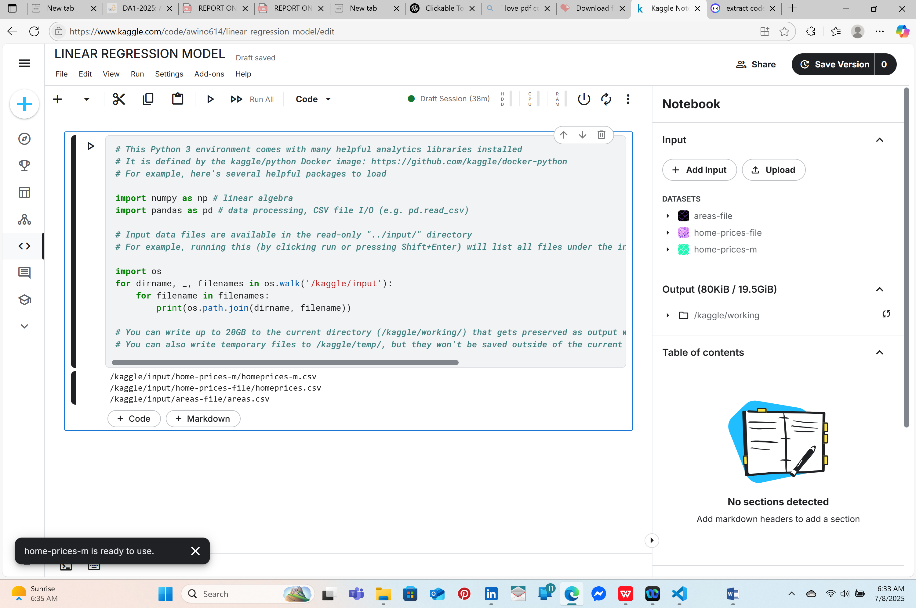

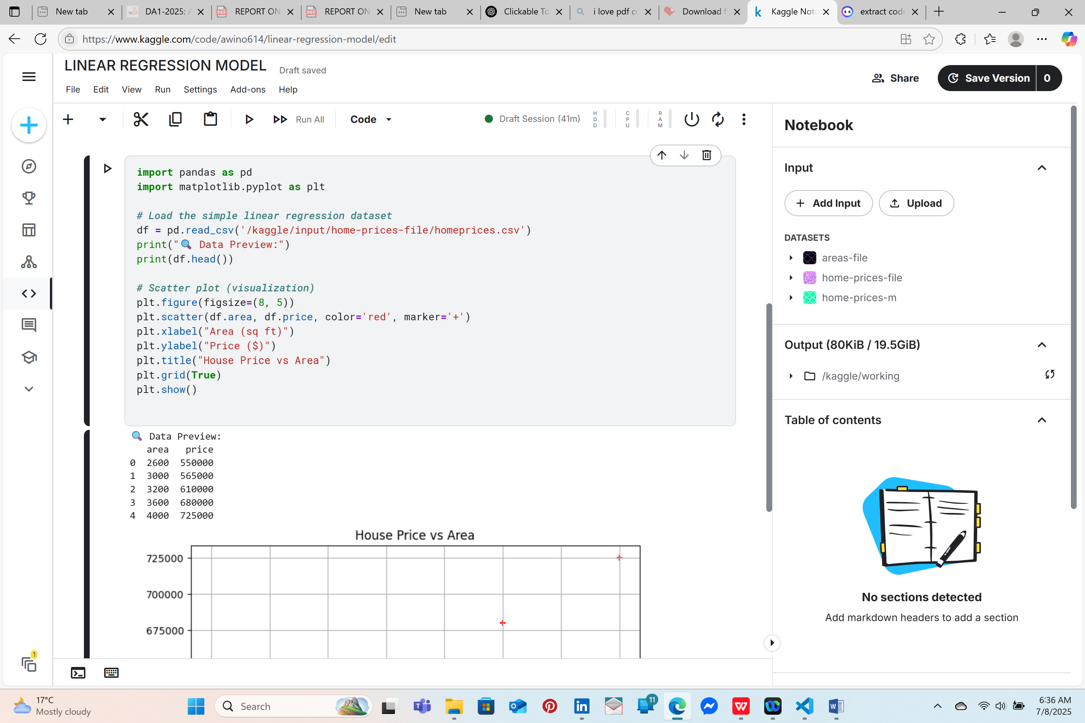

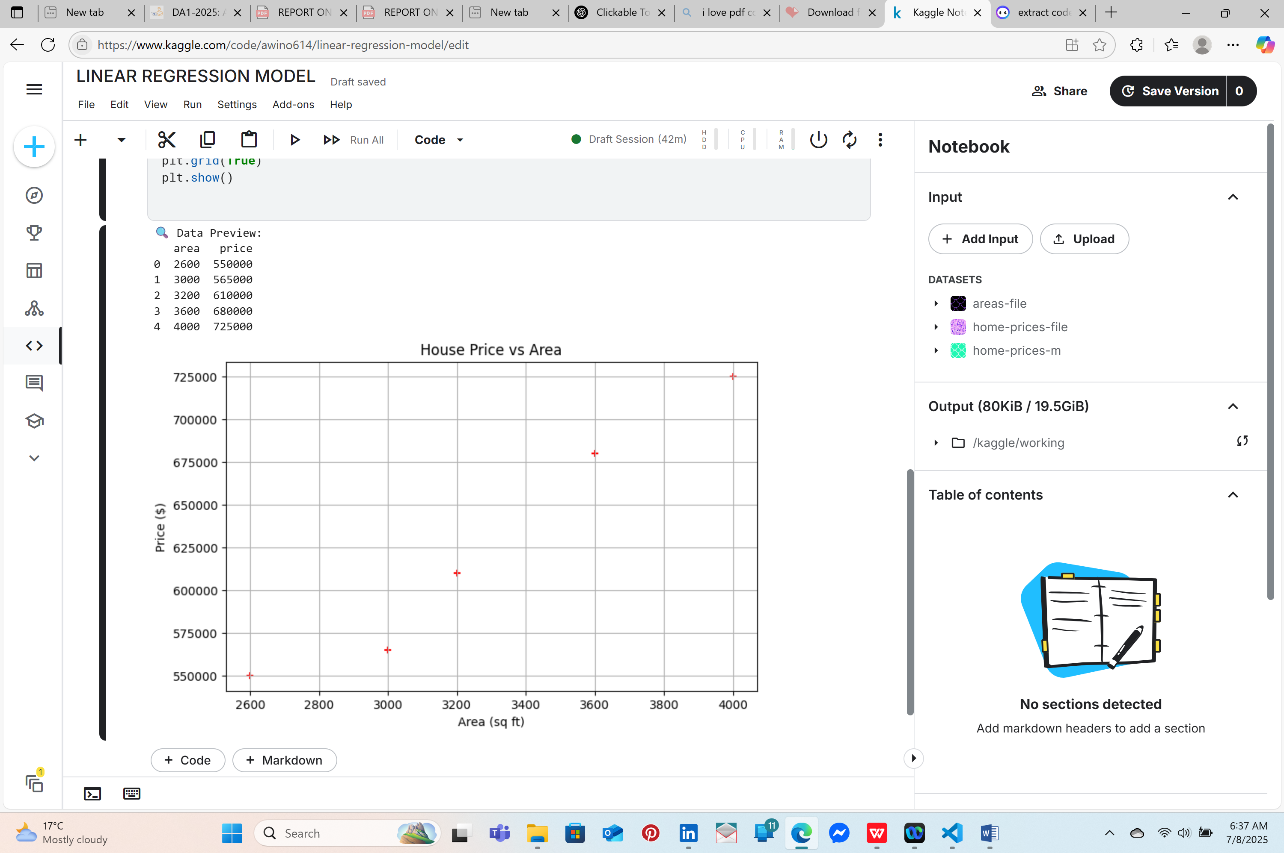

*2.****TRAINS A SIMPLE LINEAR REGRESSION MODEL***

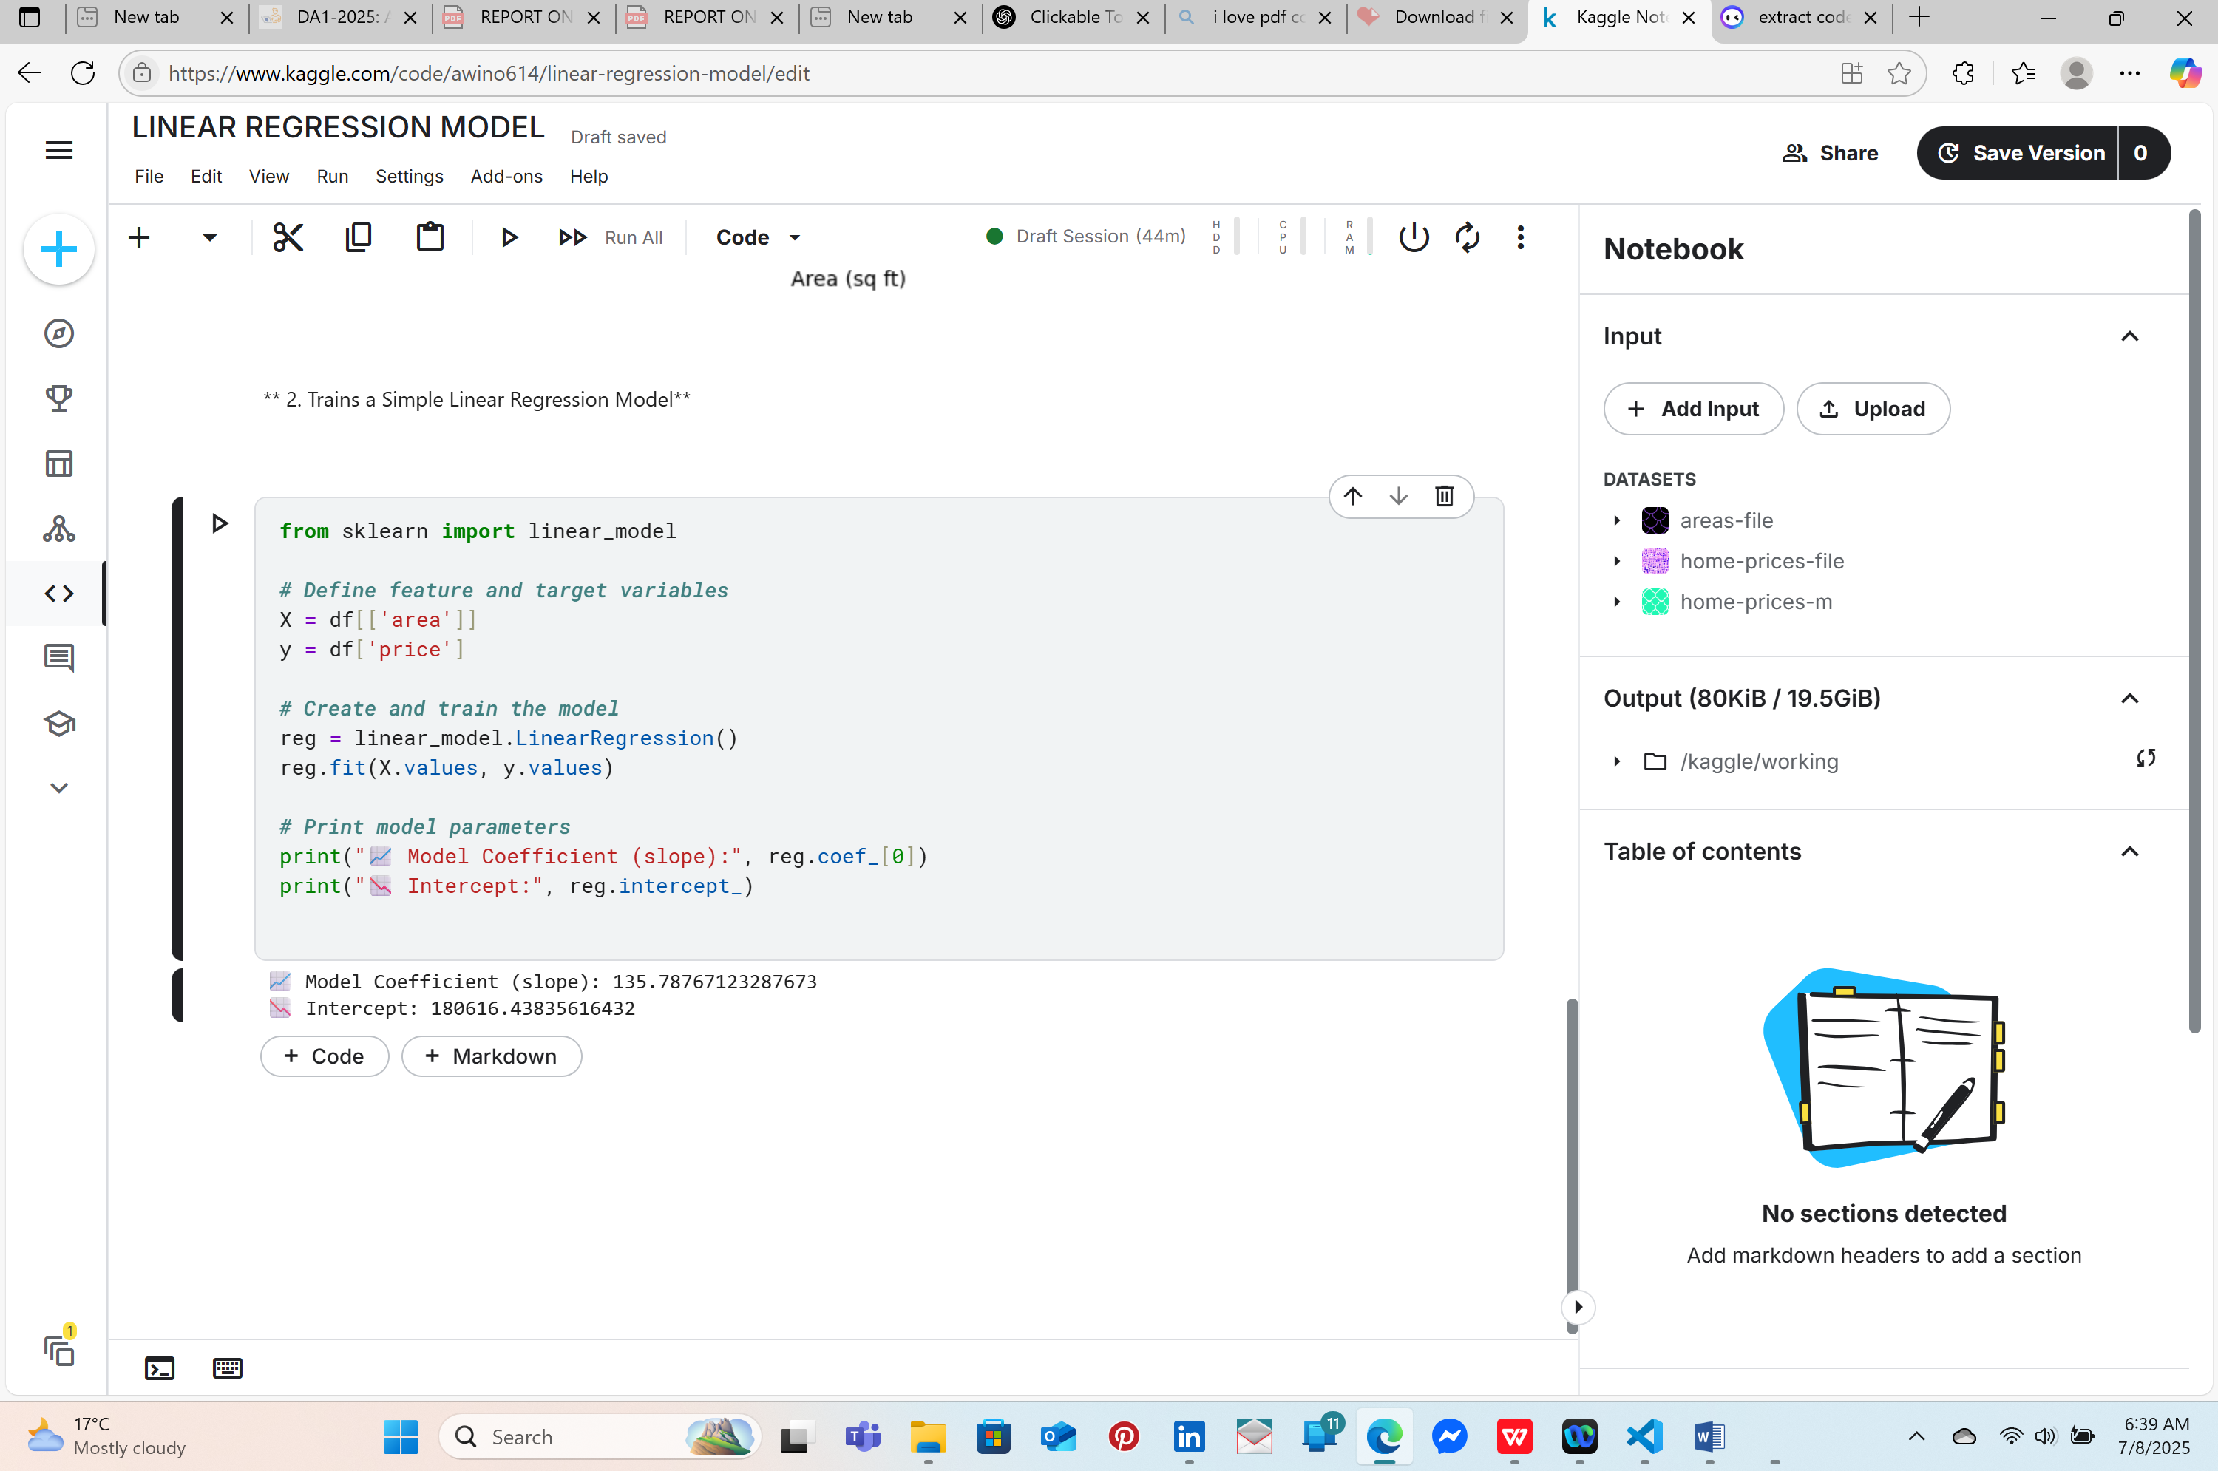

*3.****MAKES SINGLE AND BATCH PREDICTIONS***

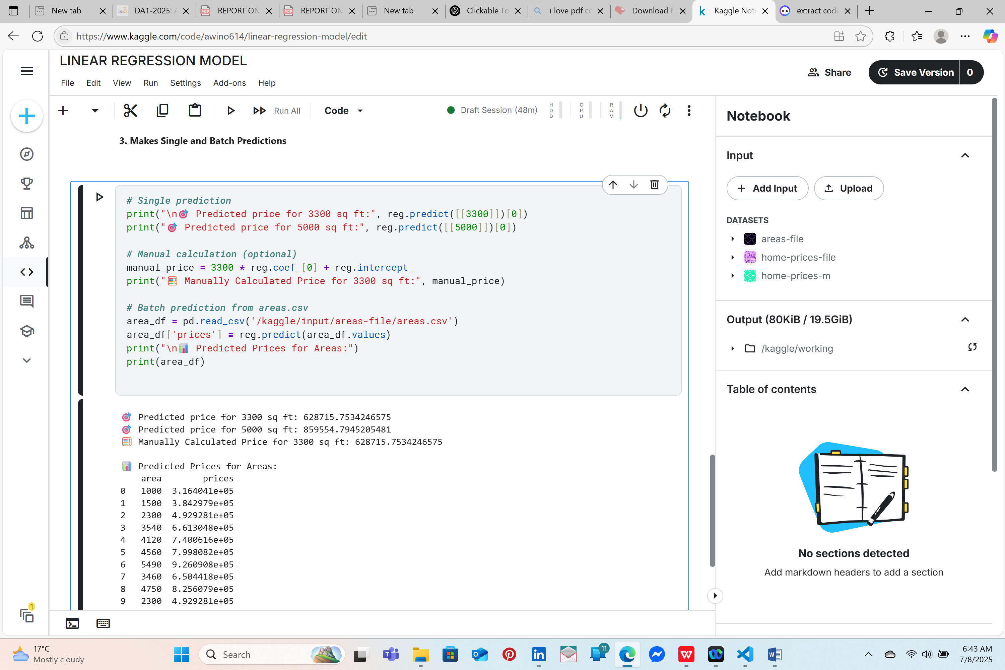

*4.****EVALUATES PERFORMANCE (MAE, MSE, RMSE, R²)***

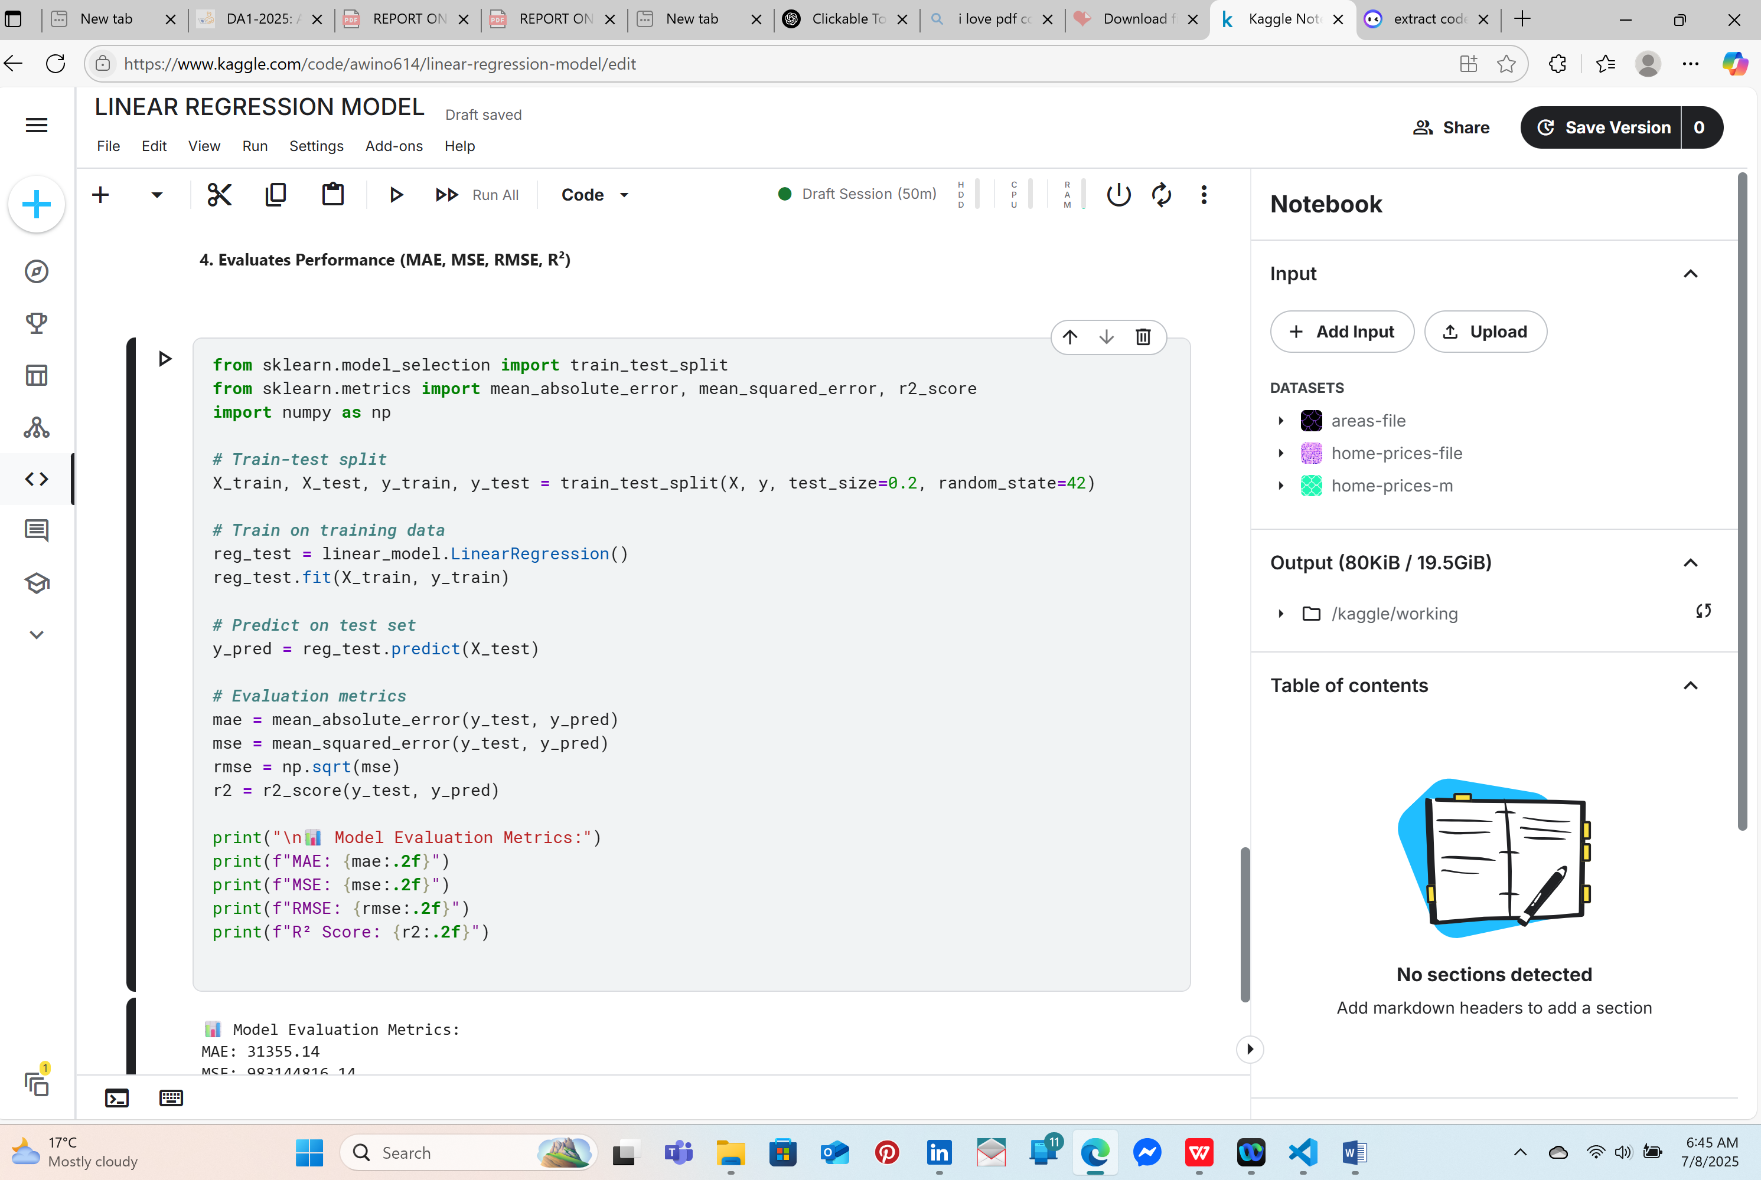

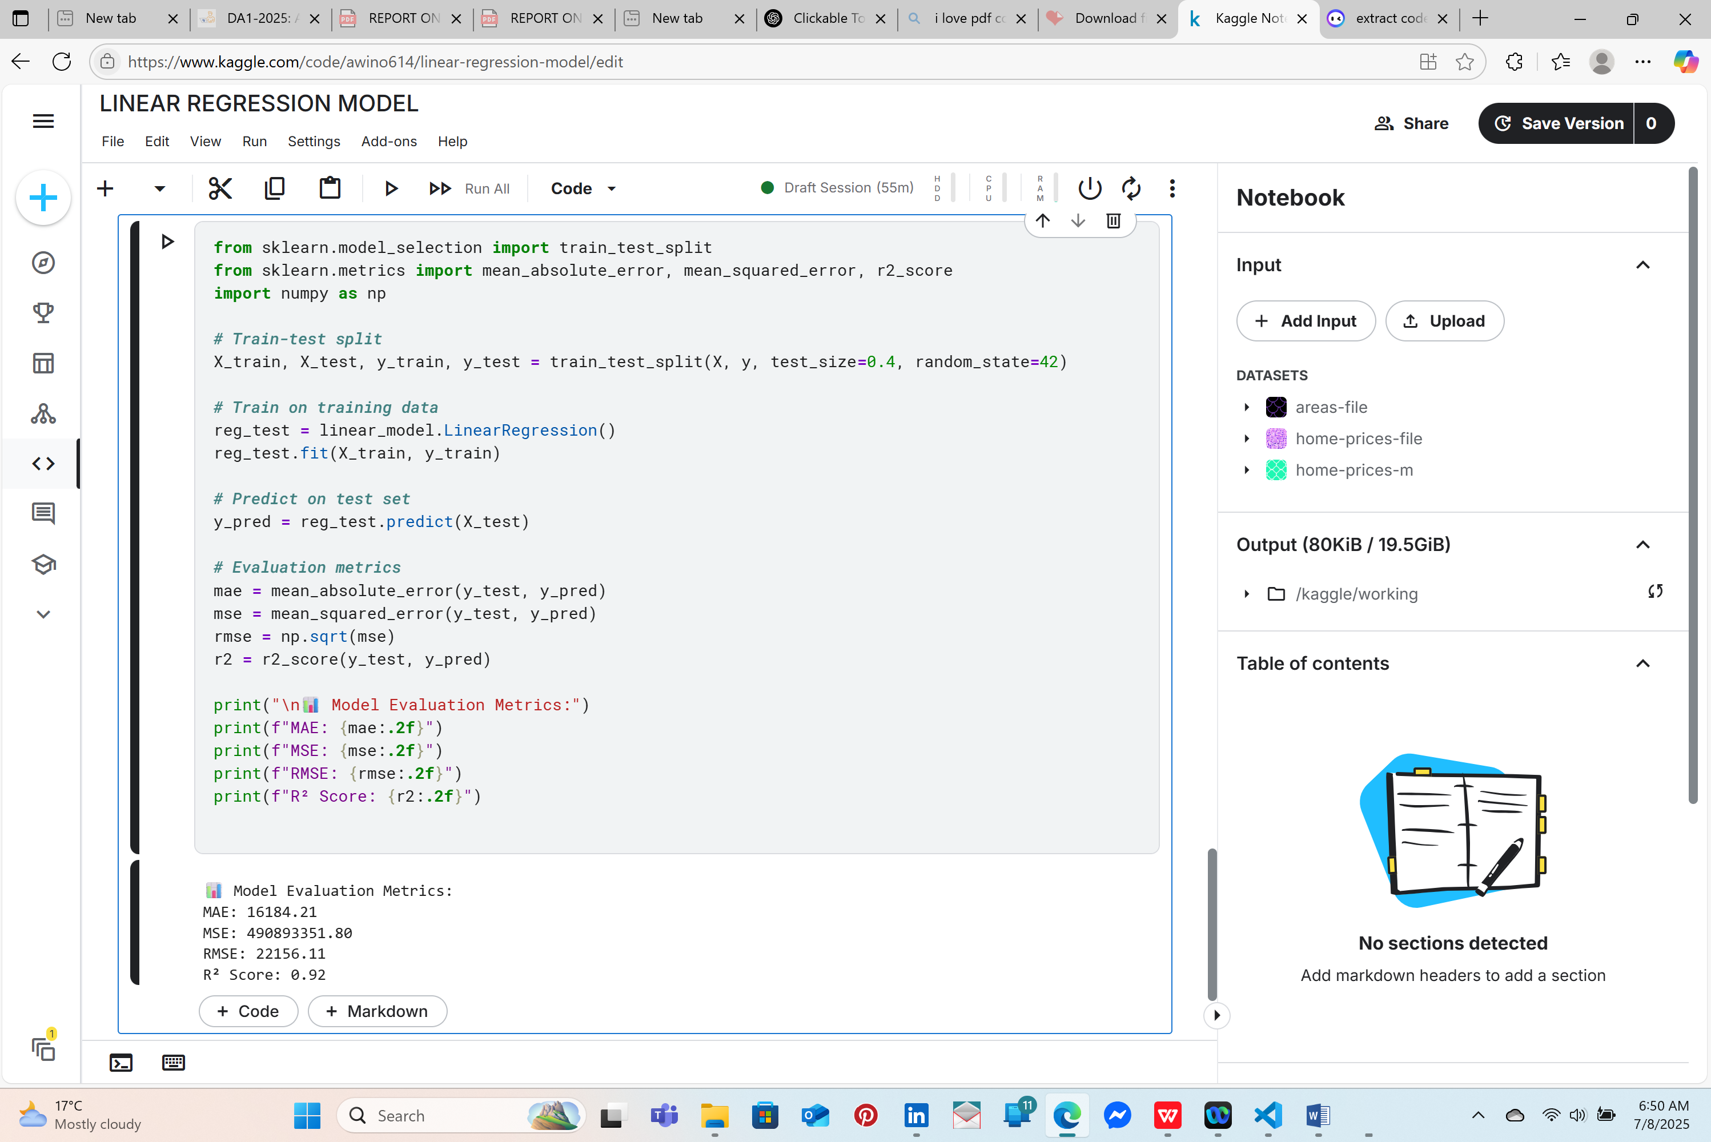

*5.****VISUALIZES THE REGRESSION LINE***

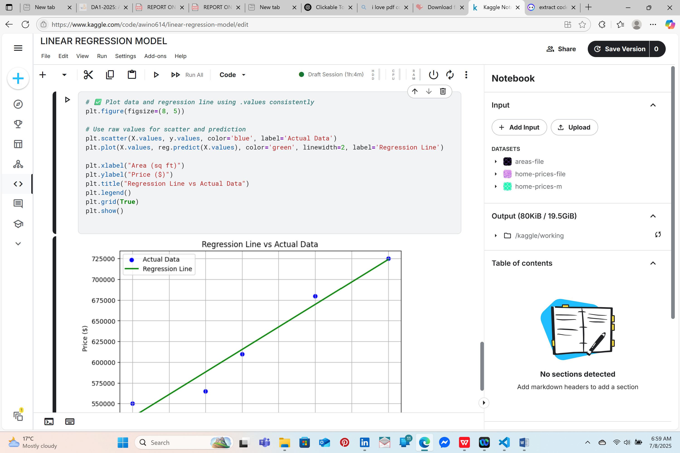

*6.CHECK FOR MISSING VALUES*

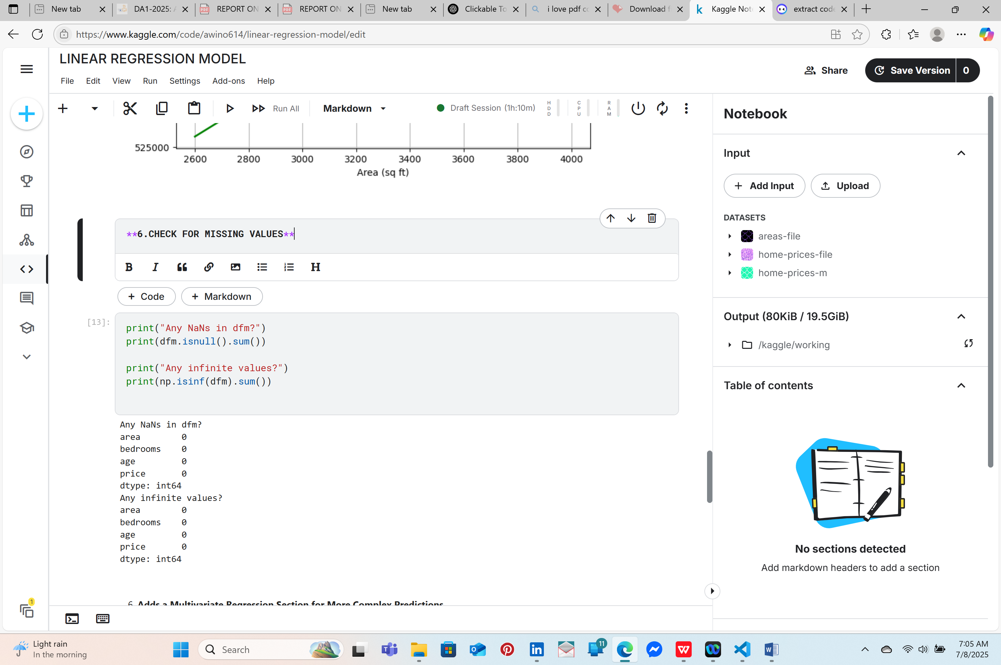

*7.ENSURE ALL NAN ARE FILLED AND REPRINT THE COEFFICIENTS CAREFULLY*

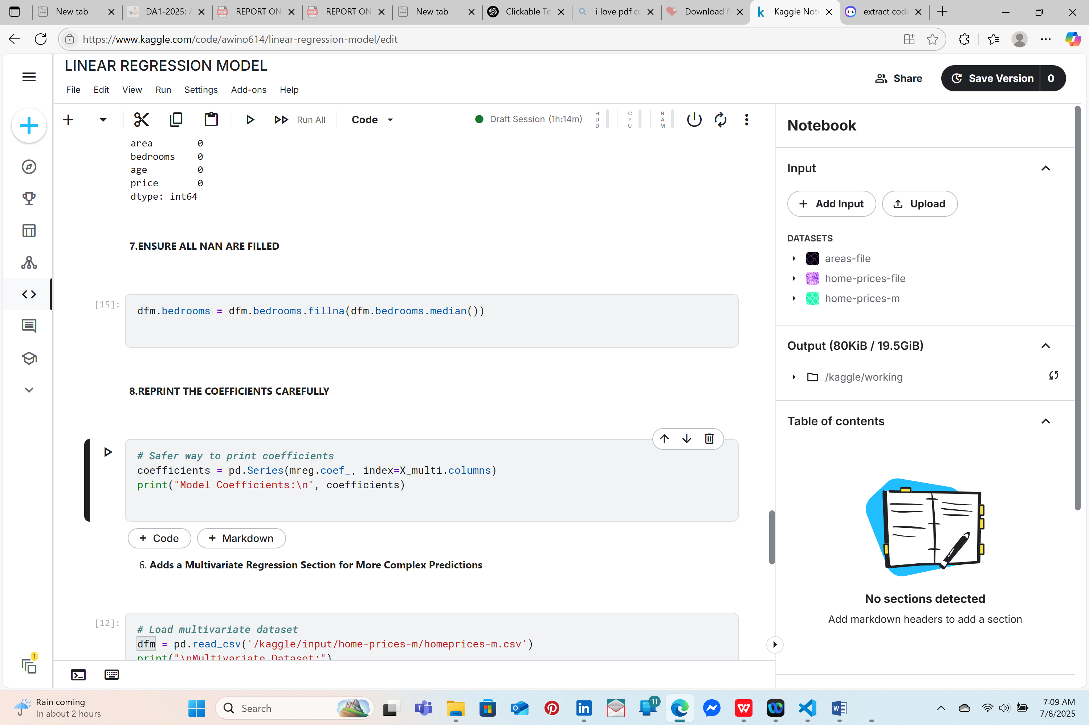

***8.ADDS A MULTIVARIATE REGRESSION SECTION FOR MORE COMPLEX PREDICTIONS***

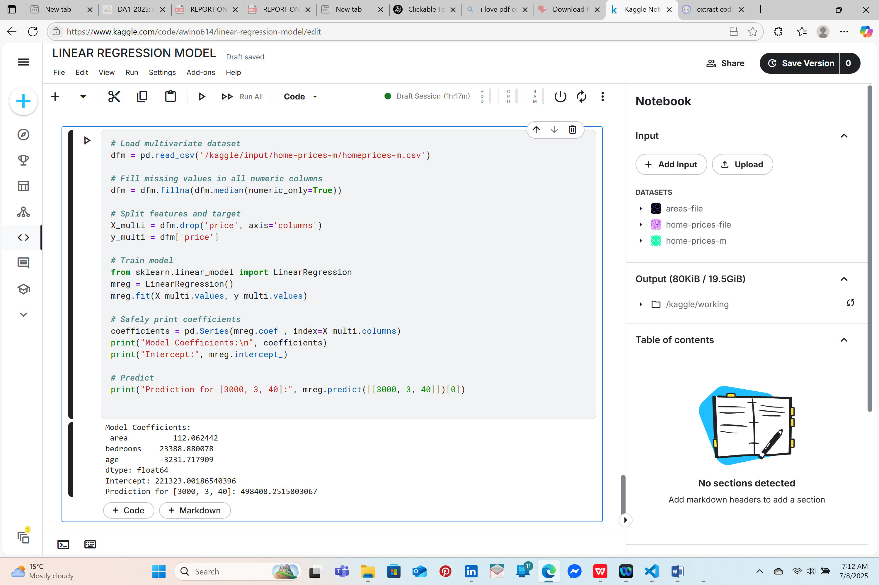

***9.EXPORTS PREDICTIONS TO A CSV FILE FOR YOUR PORTFOLIO***

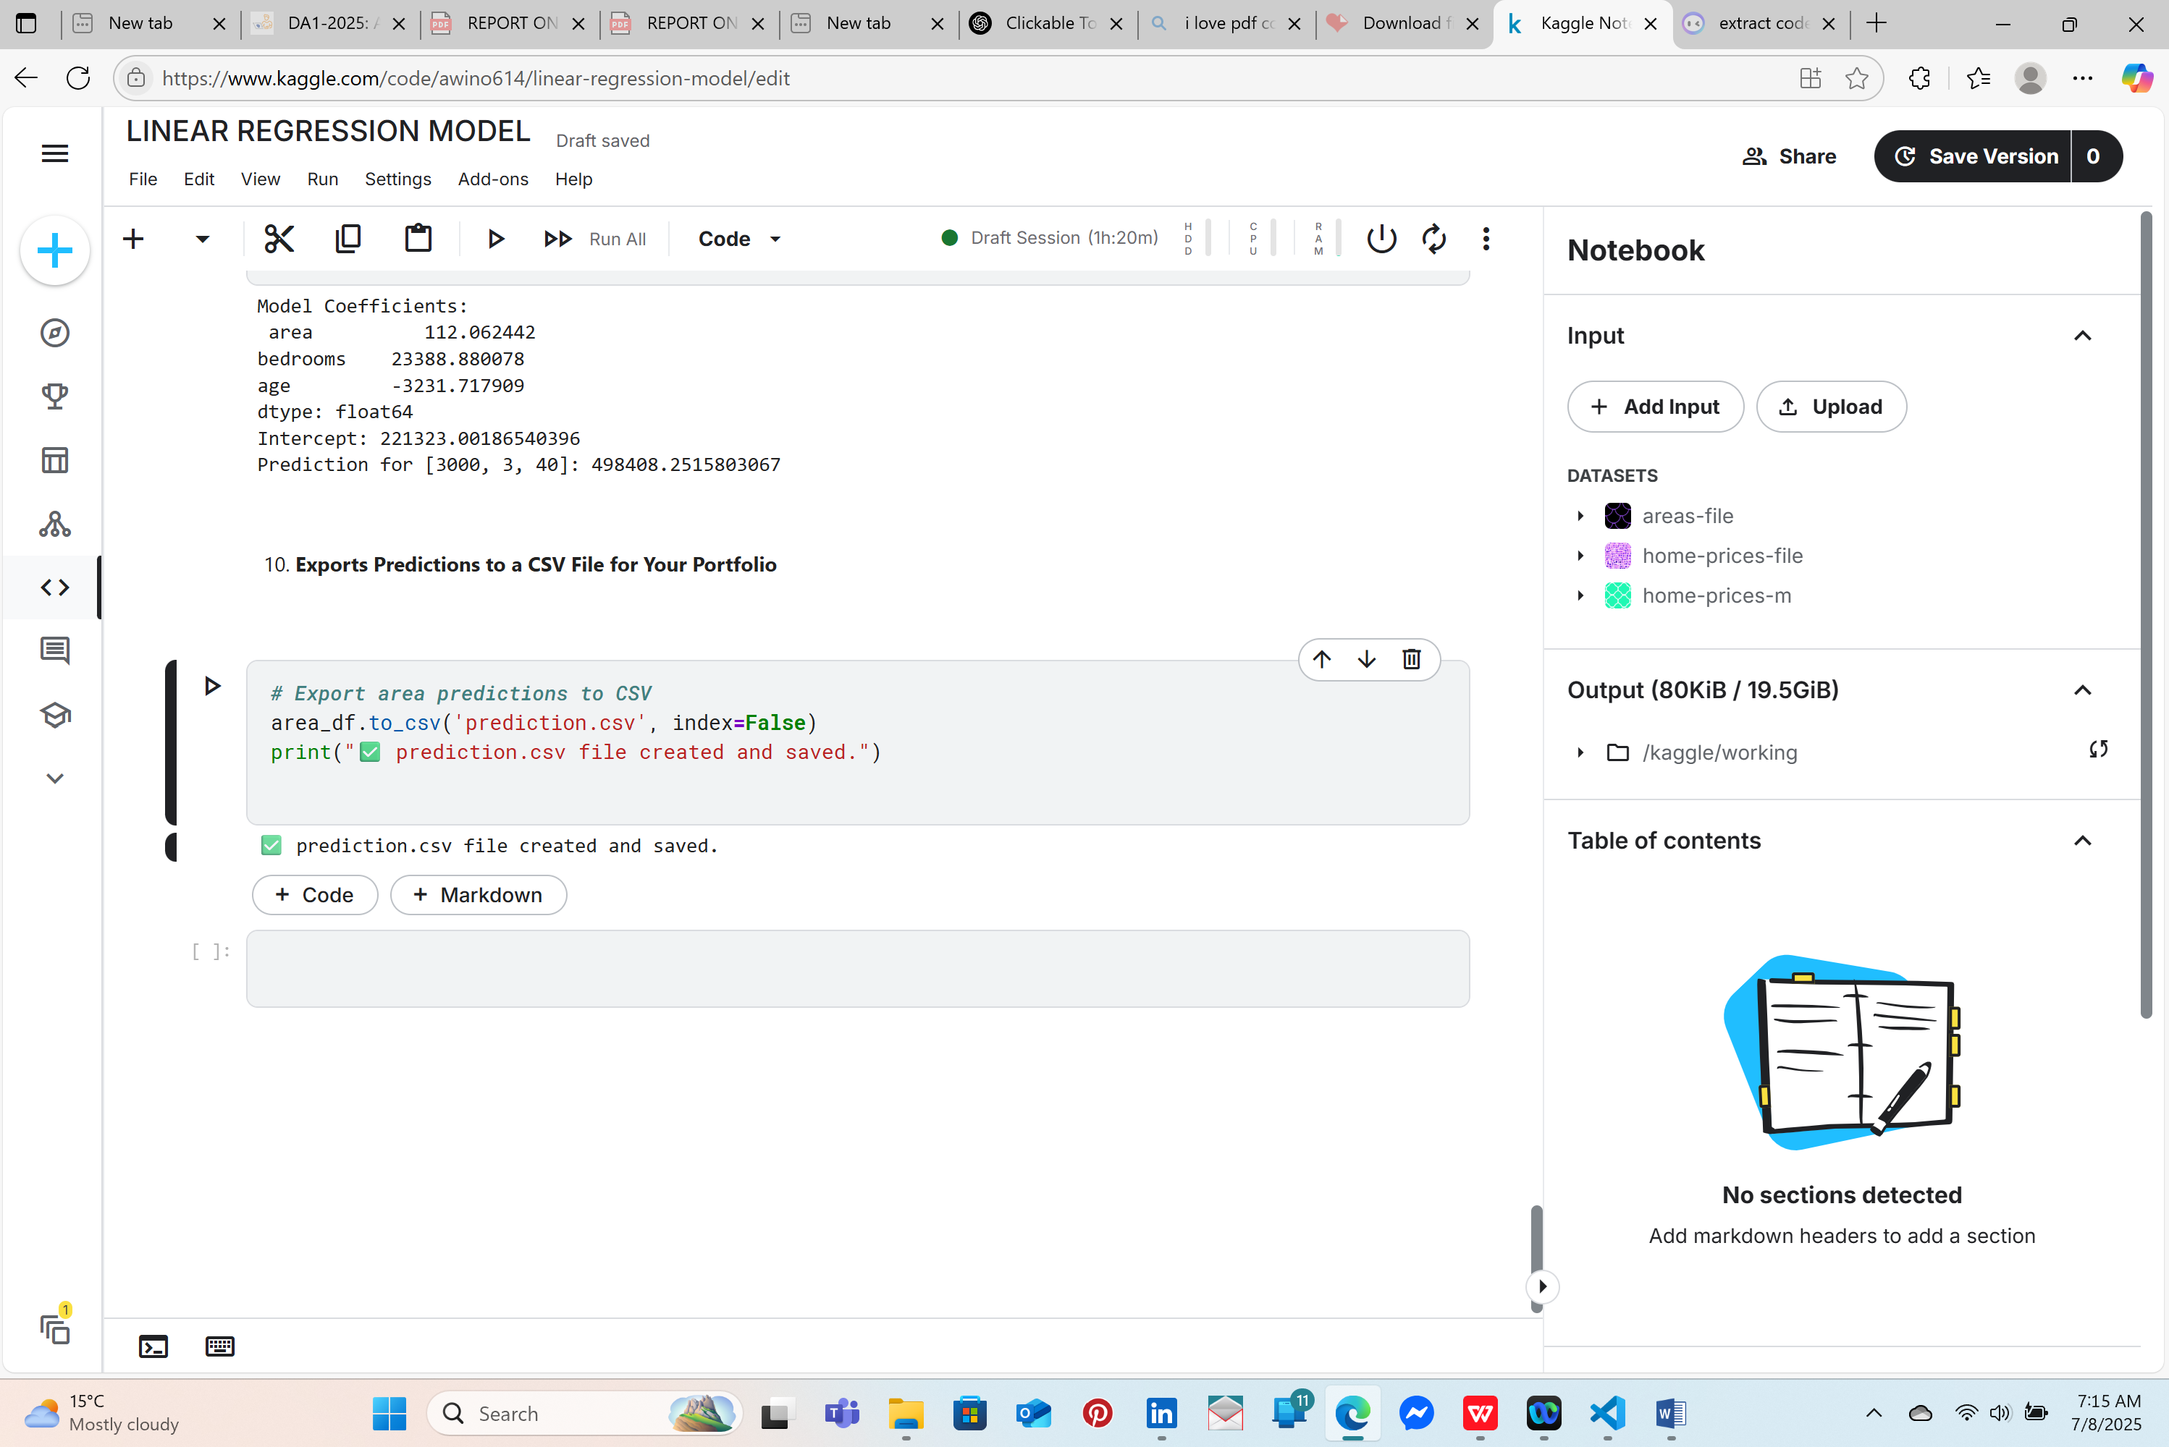

**CONCLUSION**

This project successfully demonstrated the practical application of **Linear Regression** to predict housing prices using Python and Scikit-learn. Through both simple and multivariate models, we explored how linear relationships between variables—such as area, number of bedrooms, and age—can be effectively leveraged to make accurate predictions.

In the **Simple Linear Regression** section, we modeled the relationship between a single independent variable (area) and house price. We visualized this relationship using scatter plots and regression lines, and evaluated the model using performance metrics like MAE, MSE, RMSE, and R² score.

The **Multivariate Linear Regression** model expanded the analysis to include multiple features, providing a more comprehensive view of factors affecting housing prices. By handling missing values, training the model, and making predictions based on real-world input scenarios, we deepened our understanding of regression modeling in more complex data contexts.

Finally, we exported the predictions to a CSV file, enabling the results to be used for future analysis, presentation, or portfolio showcasing. This end-to-end process—from data exploration to model deployment—highlights the essential workflow of a data science or machine learning project.

Overall, the project not only strengthened foundational skills in machine learning but also emphasized the importance of data preprocessing, model evaluation, and interpretability in building reliable prediction systems.

**REFERENCE**

1 • **Pedregosa, F., Varoquaux, G., Gramfort, A., Michel, V., Thirion, B., Grisel, O., ... & Duchesnay, É. (2011).**  
*Scikit-learn: Machine Learning in Python.* Journal of Machine Learning Research, 12, 2825–2830.  
<https://scikit-learn.org/>

2 • **Hunter, J. D. (2007).**  
*Matplotlib: A 2D Graphics Environment.* Computing in Science & Engineering, 9(3), 90–95.  
<https://matplotlib.org/>

3 • **Pandas Development Team (2023).**  
*pandas: Powerful Python data analysis toolkit.*  
https://pandas.pydata.org/

4 • **NumPy Developers (2023).**  
*NumPy: The fundamental package for scientific computing with Python.*  
<https://numpy.org/>

5 • **homeprices.csv, homeprices-m.csv, and areas.csv datasets**  
Provided for educational purposes as part of machine learning coursework.

6 • **Python Software Foundation (2023).**  
*Python Language Reference, version 3.10.*  
<https://www.python.org/>

7 • Géron, A. (2019).  
*Hands-On Machine Learning with Scikit-Learn, Keras, and TensorFlow (2nd Edition).* O’Reilly Media.